CHAPTER 11: UNDERSTANDING DIALOG BOXES

1. What is a Dialog Box?

A **dialog box** is a pop-up window that a program uses to talk to you. While menus give you simple choices, dialog boxes let the program ask for more details. They usually contain things like:

* **Text boxes** (where you type information).
* **Buttons** (like "OK" or "Cancel").
* **Radio buttons** (where you pick one option from a list).

2. How Dialog Boxes are Made

1. **Templates:** Developers use a "blueprint" called a template. This tells the computer how big the window should be and where to put the buttons.
2. **Design Tools:** Programs like **Visual Studio** let developers "draw" the dialog box. The software then writes the difficult code for them automatically.

How They Work (The "Manager")

When a dialog box pops up, Windows takes over the hard work. A built-in system called the **Dialog Box Manager** handles the mouse clicks and keyboard typing for that window.

1. The Dialog Procedure

Even though Windows does the heavy lifting, the programmer still writes a small set of instructions called a **Dialog Procedure**. This code does three main things:

* Sets up the box when it first opens.
* Reacts when you click a button (like saving your work).
* Closes the window when you are finished.

2 Why Use Dialog Boxes?

In earlier chapters, making buttons and text boxes manually was very difficult. Dialog boxes make it **much easier** because:

* Windows automatically moves the "focus" (the cursor) from one box to the next when you press the **Tab** key.
* The system handles the layout so the programmer doesn't have to worry about every tiny detail.

Modeless Dialog Boxes: Staying Open While You Work

In the last section, we looked at **Modal** dialog boxes. Now, let's look at a more flexible version called **Modeless** dialog boxes.

**Modal vs. Modeless: What’s the Difference?**

Think of it like this:

* **Modal (The "Strict" Box):** This is like a pop-up that demands your full attention. You *must* click "OK" or "Cancel" before you can click on anything else in the main program. It "locks" the rest of the app until you're done with it.
* **Modeless (The "Friendly" Box):** This is like a floating tool window. You can leave it open on the side and still click back and forth between the box and your main work. It doesn't lock you out of anything.

1. Why Use Modeless Boxes?

Modeless boxes are great because they make things smoother for the user:

* **No Constant Opening/Closing:** You can keep the box open for reference while you type in the main window. You don't have to keep re-opening it every time you need it.
* **Better Multitasking:** It feels more natural. You can look at information in the dialog box and use that info to finish a task in the main program at the same time.
* **Speed:** Since you aren't forced to close the window to get back to work, you save time and clicks.

2. How the Computer Handles Them

To make these boxes work, programmers use two different "commands" (functions):

3. Code Comparison:

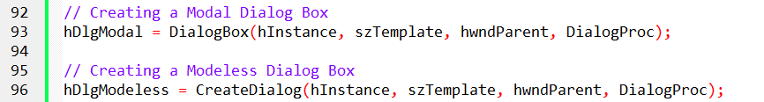

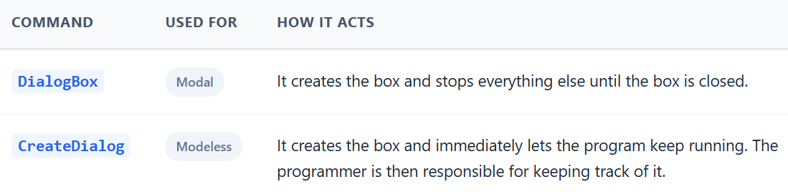

A **Modal** box is a "stop sign"—you have to deal with it before moving on. A **Modeless** box is a "sticky note"—it stays on your screen while you keep working on other things.

4. How to Remember the Names

If you’re a programmer, the names of the commands (functions) actually give you a hint about what they do:

* **DialogBox (Modal):** Think of this as a "box" that traps the user. You can’t leave it until you’re done.
* **CreateDialog (Modeless):** This sounds like CreateWindow. That’s because it acts like a normal, independent window that lives alongside your main program.

5. What Do They Look Like?

Modeless boxes look a bit more "official" than standard modal boxes.

* **The Top Bar:** Modeless boxes usually have a **Caption Bar** (the title bar at the top) and a **System Menu** (the icon in the corner). This lets you grab the window and move it around while you work.
* **Showing Up:** Modal boxes pop up automatically. Modeless boxes are usually "shy"—they are hidden by default. The programmer has to tell them to "Show Up" (using a command called ShowWindow) or mark them as "Visible" in the blueprint.

6. The "Mailroom" Problem (Message Handling)

This is the most technical part, but here is the simple version:

Every Windows program has a "mailroom" (called a **Message Queue**) that sorts through clicks and keypresses.

1. **The Confusion:** When you have a Modeless box open, the "mailroom" gets confused. It doesn't know if a mouse click belongs to the main window or the dialog box.
2. **The Filter (IsDialogMessage):** The programmer adds a special filter. Before sorting any mail, the program asks: *"Is this for the Dialog Box?"* * If **Yes**, the box handles it immediately. If **No**, the mail goes to the main program like normal.
3. **Keyboard Shortcuts:** If your program uses "hotkeys" (like Ctrl+S to save), the mailroom has to be even more careful to make sure those shortcuts don't accidentally trigger something inside the dialog box instead.

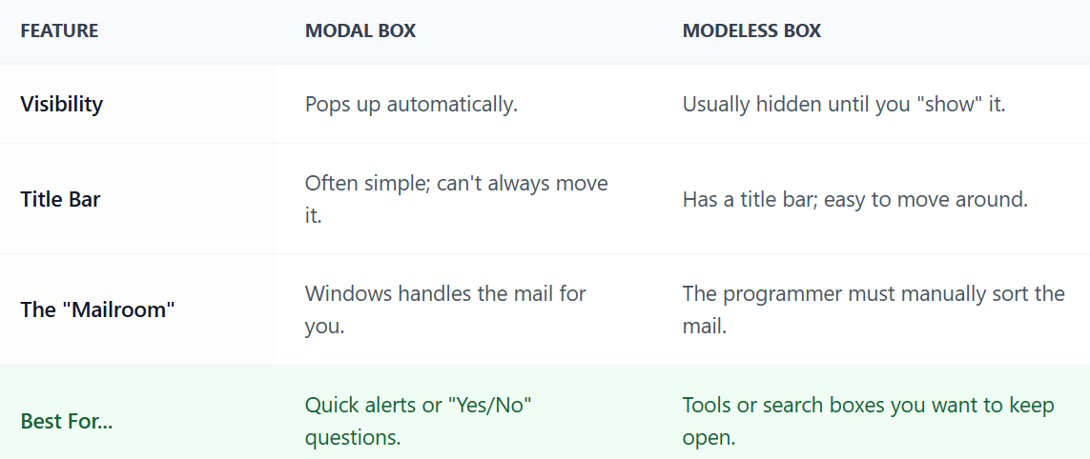

7. Which should you choose?

It depends on the "vibe" of your app. If the user **must** answer a question before continuing, go **Modal**. If you want to give them a tool they can use whenever they want, go **Modeless**.

8. Code Comparison 2:

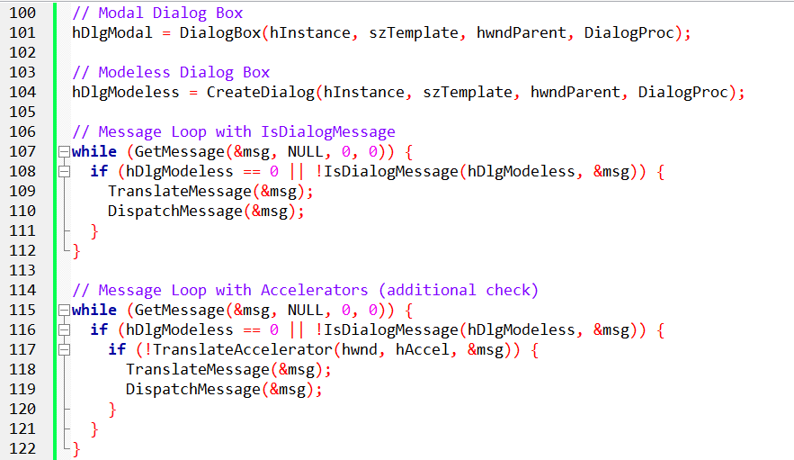

9. Important Things to Keep in Mind

Because **Modeless** boxes stay open, the programmer has a few extra "housekeeping" chores to do:

* **Who is the "Focus" on?** The program has to be smart about where the typing goes. If you click the dialog box, the keyboard should work there. If you click the main window, it should switch back smoothly.
* **Cleaning Up Memory:** Since a Modeless box can stay open for a long time, the programmer must be careful to "delete" it from the computer's memory properly when it is finally closed. If they don't, the computer might slow down.
* **Don't Clutter the Screen:** Just because you *can* have five Modeless windows open doesn't mean you *should*. Too many floating windows make a program messy and hard to use.

10. Comparing the Two (Visual Example)

Imagine you are using an app and two windows pop up. Here is how you can tell them apart:

I. The Modal Dialog Box (The "Gatekeeper")

* **No "Handle":** Usually doesn't have a top title bar or a menu icon.
* **Solid:** You can’t see through it.
* **Strict:** You are "stuck" here until you click a button to close it.

II. The Modeless Dialog Box (The "Assistant")

* **Has a "Handle":** It has a title bar so you can drag it out of the way.
* **See-through:** It is often semi-transparent so you can still see your work behind it.
* **Flexible:** You can go back to your main work without closing this box first.

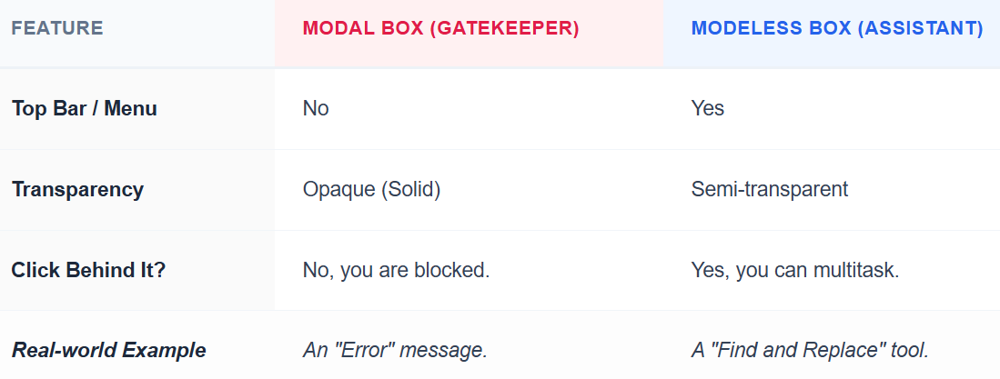

III. In the Example

Think of an app like **Microsoft Word**:

* The **"Confirm Exit"** window (Do you want to save?) is **Modal**. You have to answer before you do anything else.
* The **"Find"** window (Search for a word) is often **Modeless**. You can keep it open while you continue to type your document.

Here is a table that summarizes the key differences between modal and modeless dialog boxes:

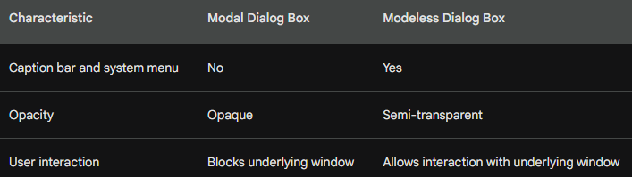

The "ID Card": hDlgModeless

In your code, you create a special variable called hDlgModeless. Think of this as the **ID Card** for your dialog box.

* **Is it open?** If the ID Card is empty (zero), the program knows the box isn't open.
* **Talking to others:** Other parts of your program use this ID to "call" the dialog box and share information.
* **Closing time:** When it’s time to close the window, the program looks at this ID to make sure it shuts down the right one.

1. How to Close the Box

Closing a **Modeless** box is different from closing a regular (Modal) one.

* **The Command:** Instead of saying "End Dialog," the programmer must use a command called **DestroyWindow**.
* **The "X" Button:** When a user clicks the "Close" (X) button, the program sends a message called WM_CLOSE. The programmer has to write a rule that says: *"When you see WM_CLOSE, destroy the window and set the ID Card back to zero."*
* **Memory Cleanup:** Setting the ID (hDlgModeless) to NULL (zero) is like hanging up a phone—it tells the computer the connection is officially over so it can save memory.

2. Using Buttons to Close

If you put a "Close" or "Cancel" button inside the box, it works just like the "X" button. When the user clicks it, the program runs the DestroyWindow command and clears the ID Card.

3. Sharing Information

How does the main program know what you typed into the dialog box? There are two main ways to share data:

* **The "Public Bulletin Board" (Global Variables):** You save the information in a spot where the whole program can see it. It’s easy to do but can get messy if you have too many.
* **The "Briefcase" (CreateDialogParam):** This is a more professional way. You "hand over" a specific folder of information directly to the dialog box when you create it.

4. Organizing the "Mail" (The Message Loop)

As we mentioned before, the "mailroom" (the message loop) needs to stay organized.

The program uses a filter called **IsDialogMessage**. It works like a mail sorter:

1. **Check:** "Is this mail for the Dialog Box?"
2. **Sort:** If yes, send it to the box. If no, send it to the main program.
3. **Shortcut Check:** If you use keyboard shortcuts (like **Ctrl+C**), the program adds one more step to make sure the shortcut goes to the right place.

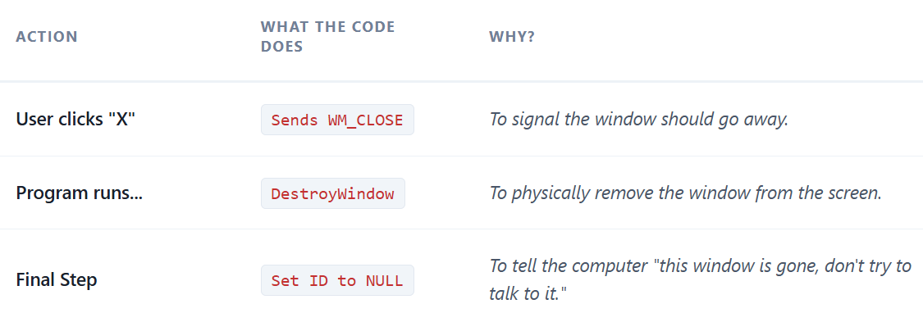

hDlgModeless Global Variable:

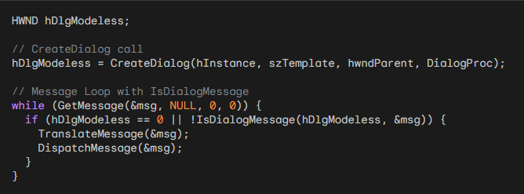

Ending a Modeless Dialog Box:

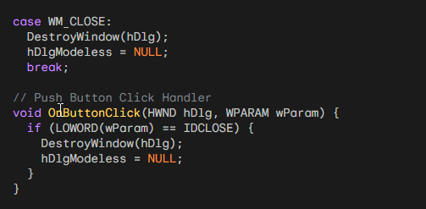

Push Button Closure:

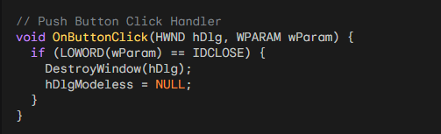

Data Exchange with Parent Window:

a) Global Variables:

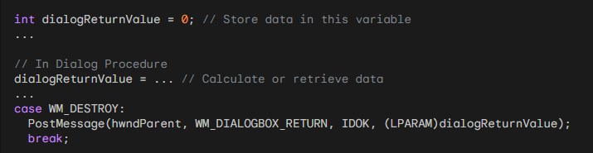

b) CreateDialogParam:

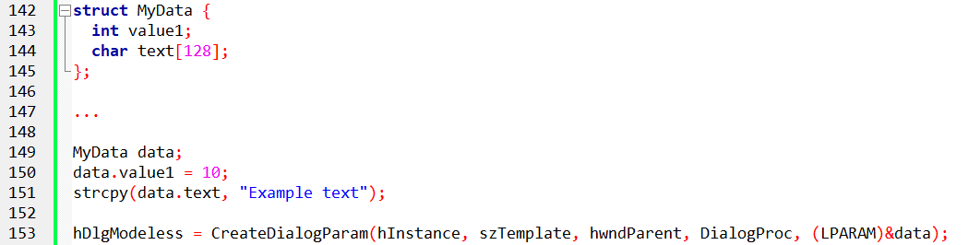

Message Loop Orchestration:

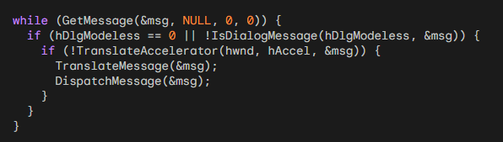

Colors2 program in chapter 11 folder….



COLORS2: The "Cleaner" Way to Code

In the previous version (COLORS1), the programmer had to manually build and manage nine different tiny windows for the scroll bars and text. It was a mess.

**COLORS2** fixes this by using a **Modeless Dialog Box**.

1. Why it’s better (The "Big Win")

* **The Code is Cleaner:** The main window's brain (WndProc) doesn't have to do much anymore. It basically just says, "Let the Dialog Box handle the colors; I'm just here to show the results."
* **Automatic Layout:** Instead of writing code to place every scroll bar exactly 10 pixels apart, the programmer just "draws" the box in a resource file.
* **No "Dead" Windows:** Because it's modeless, the main window stays active. You can move the dialog box to the side and still interact with the main window.

2. How the Parts Talk to Each Other

Even though the code is simpler, the different parts of the program still need to communicate:

* **The Setup:** The program starts the main window and then immediately pops up the "Color Scroll" box using CreateDialog.
* **The Scroll:** When you move a scroll bar (Red, Green, or Blue), the **Dialog Box** handles that message.
* **The Update:** As soon as you move a slider, the dialog box tells the main window: *"Hey, the user picked a new color! Update your background now."*
* **The "Safety" Style:** The main window uses a style called WS_CLIPCHILDREN. This is just a fancy way of saying: "Don't accidentally erase the dialog box when you're painting the background color."

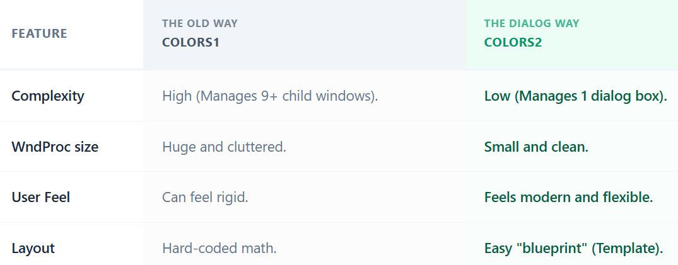

Instead of building a car engine piece-by-piece on your driveway (COLORS1), you’re essentially buying a "pre-made engine block" (the Dialog Box) and just plugging it in.

It saves time, prevents bugs, and makes the program much easier to read.

3. The "Mail Sorter" (The Message Loop)

This is the core of a modeless program. It’s like a post office that check's the address on every piece of mail before delivering it.

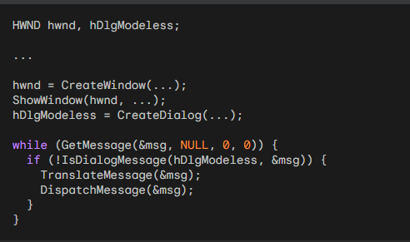

By adding IsDialogMessage, you don't have to write any code in your main WndProc to handle the scroll bars. The "mail" for the scroll bars is intercepted and sent straight to the dialog box.

4. The Dialog Logic: Short and Sweet

Inside the **Dialog Procedure**, the code uses the ID numbers of the scroll bars (10, 11, and 12) to figure out which color you are changing.

* **GetWindowLong**: Finds out which scroll bar (Red, Green, or Blue) was touched.
* **SetScrollPos**: Moves the little slider thumb to the new spot.
* **SetDlgItemInt**: Instantly updates the number shown in the text box next to the slider.
* **Final Action**: It tells the main window to repaint itself with the new RGB color.

5. The Resource Script: The "Drawing"

Instead of hundreds of lines of CreateWindow code, the layout is defined in a simple text file (the Resource Script). It looks like this:

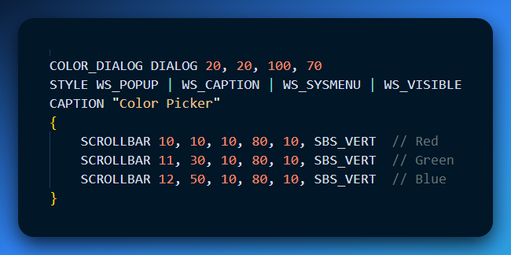

Defines the layout and appearance of the dialog box using controls like scroll bars, static text fields, and labels.

HEXCALC PROGRAM

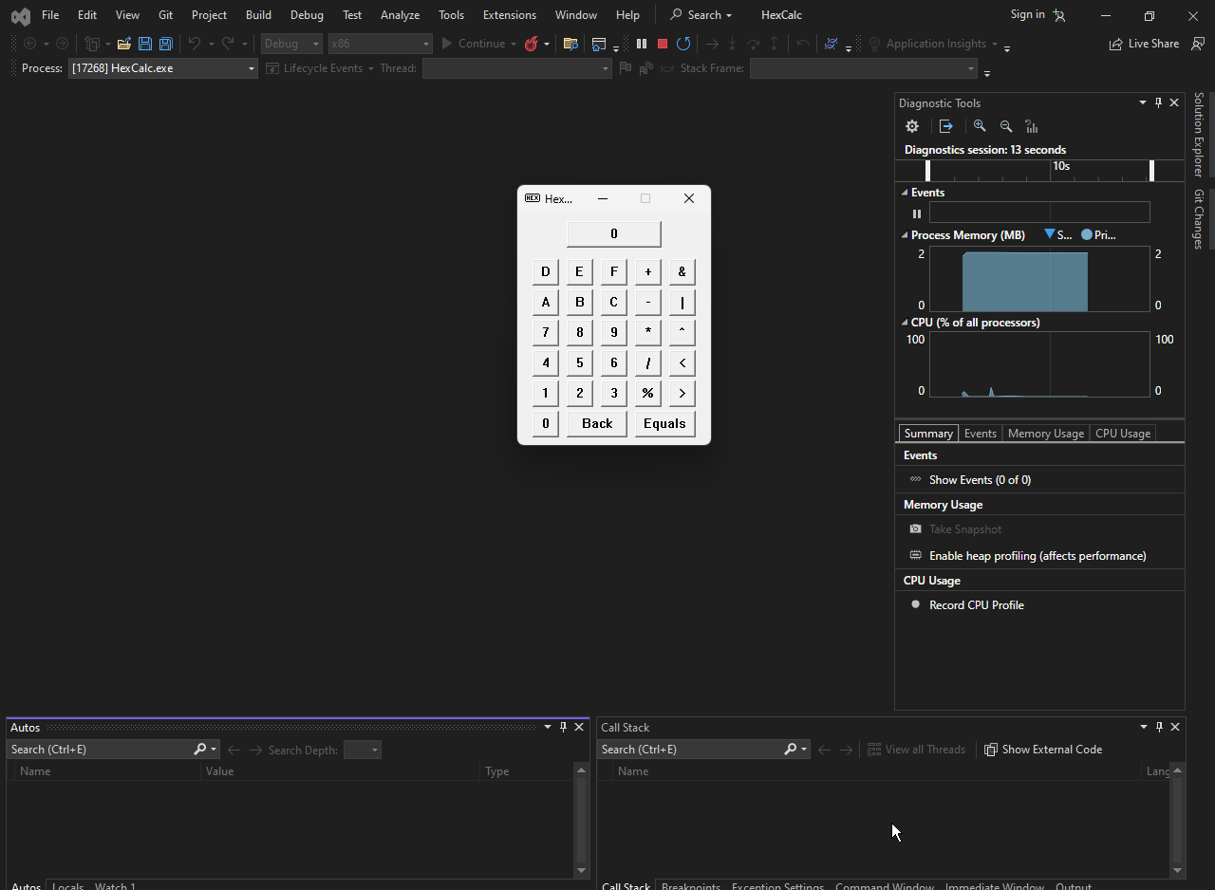

HEXCALC: The "Lazy" Genius Method

Normally, to make a calculator, you have to manually place every button and define how they look. HEXCALC skips all that by using a **Dialog Box as the main window.**

1. Why it’s "Lazy" (and Smart):

* **No CreateWindow Mess:** Instead of coding 20+ buttons for numbers and math symbols, the programmer just draws them in a Resource File.
* **Under 150 Lines:** Because Windows handles the buttons, the actual code is incredibly short.
* **Hybrid Style:** It looks like a dialog box, but it acts like a real program. It even supports keyboard shortcuts (like pressing "Enter" for "Equals").

2. What can it do?

Even though it’s small, it’s a powerhouse for programmers:

* **Hex-Only:** It works in Hexadecimal (Base-16), using numbers 0–9 and letters A–F.
* **Big Numbers:** It handles 32-bit integers (up to FFFFFFFF).
* **Math & Logic:** It does the basics (plus, minus, multiply) but also "geeky" stuff like Bitwise AND/OR and Bit Shifting.
* **Feels Real:** It even has a tiny "Sleep" command in the code so when you click a button, it pauses for a millisecond to look like a physical button being pressed.

3. The Technical "Cheat Code"

The secret to HEXCALC is how it handles messages. Even though it's a dialog box, it uses a **custom WndProc**.

**The Blueprint:** The HEXCALC.DLG file tells Windows exactly where the buttons go.

**The Brain:** The WndProc watches for two things:

* **Mouse Clicks:** "Did the user click the 'D' button?"
* **Keyboard:** "Did the user just type 'D' on their keyboard?"

**The Result:** It treats a keypress and a mouse click exactly the same, making the code much shorter.

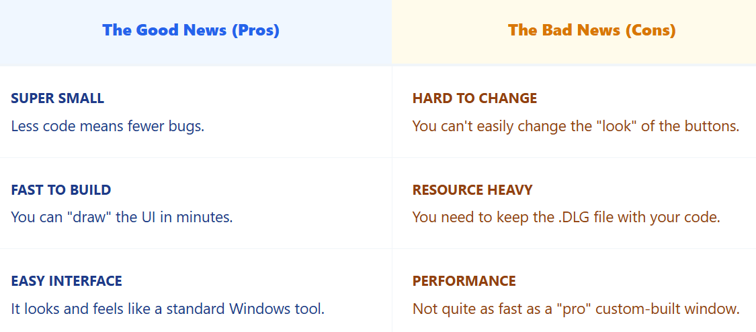

HEXCALC is a great example of **working smarter, not harder.** By letting the Dialog Box Manager do the heavy lifting, the programmer can focus on the math instead of the buttons.

4. The Hybrid Design: A Dialog with a "Class"

Most dialog boxes use a hidden, built-in "brain" provided by Windows. HEXCALC is different because it uses its own custom **WndProc** (Window Procedure).

* **The CLASS Statement:** Inside the resource file, there is a line that says CLASS "HexCalc". This tells Windows: "Don't use your default settings; use my custom rules instead."
* **The Setup:** In the code, the programmer registers a window class just like a normal app, but with one special setting: DLGWINDOWEXTRA. This leaves a little extra room in memory so the custom window can act like a dialog box.

5. Smart "Lazy" Shortcuts

The programmer used two very clever tricks to keep the code tiny:

* **Buttons are IDs:** Instead of making up random numbers for button IDs (like ID_BUTTON_1), HEXCALC uses the **ASCII code** of the character on the button. For example, the ID for the 'A' button is literally the number for 'A'.
* **Two-for-One Logic:** Because the IDs match the characters, the program can use the same logic for mouse clicks and keyboard typing. It doesn't care if you clicked '7' or typed '7'—the code handles them both the same way.

6. Handling the Keyboard

To make the calculator feel "pro," the code does some quick translations behind the scenes:

* **Key Swapping:** If you press the **Left Arrow**, the program treats it as a **Backspace**.
* **Auto-Uppercase:** If you type a lowercase 'a', the program instantly turns it into a capital 'A'.
* **The Enter Key:** It treats the **Enter** key as the **Equals (=)** sign.
* **Visual Feedback:** When you press a key on your keyboard, the program sends a BM_SETSTATE message. This makes the button on the screen "flash" for 1/10th of a second so it looks like it was clicked.

5. Staying in Control (Focus)

A common problem with dialog boxes is that after you click a button, the "focus" (the blue outline) stays on that button. This can mess up keyboard typing.

* **The Fix:** Every time you click a button, HEXCALC immediately grabs the focus and moves it back to the **main window**. This ensures that the next time you type a number, the window is ready and listening.

6. Things to Remember

* **Manual Labor:** Because of its unique design, you can't use the drag-and-drop Visual Studio editor to change the HEXCALC.DLG file. You have to type the changes by hand.
* **The Balance:** This "lazy" style is perfect for small tools, but it might be too limited for a massive, complex application.
* HEXCALC is a masterclass in efficiency. It uses the **Resource Script** to build the UI, the **Dialog Manager** to create the buttons, and a **Custom WndProc** to handle the math. It’s the programming equivalent of using a "kit" to build a high-performance car.

THE COMMON DIALOG BOXES: A REVOLUTION IN STANDARDIZATION

The standardized user interface was a key objective of Windows from its inception. While achieving uniformity across various software for common menu items like "Alt-File-Open" was rapid, the actual file open dialog boxes remained diverse.

Common Dialog Box Library: A Standardized Solution

Windows 3.1 introduced the "common dialog box library," a revolutionary solution to the problem of inconsistent dialog boxes. This library provides functions that invoke standard dialog boxes for various tasks, including:

* Opening and saving files
* Searching and replacing text
* Choosing colors
* Selecting fonts (demonstrated in this chapter)
* Printing (demonstrated in Chapter 13)

Functionalities and Usage:

* **Structure Initialization:** Before invoking the dialog box, you initialize the fields of a specific structure relevant to the desired functionality.
* **Function Call:** Pass a pointer to this structure to a function in the common dialog box library.
* **Dialog Box Display:** The function creates and displays the standard dialog box for the specified task.
* **User Interaction:** The user interacts with the dialog box and makes their selections.
* **Function Return:** When the dialog box closes, the function returns control to your program.
* **Information Retrieval:** You retrieve information about the user's choices from the structure you passed to the function.

Header File and Reference Documentation:

* Include the COMMDLG.H header file in your C source code to use the common dialog box library.
* Refer to the documentation provided at /Platform SDK/User Interface Services/User Input/Common Dialog Box Library for detailed information on each function and its associated structure.

POPPAD Revisited: Implementing Common Dialog Boxes

Previously in Chapter 10, we added a menu to POPPAD but left several standard menu options unimplemented. Now, we'll enhance POPPAD3 to incorporate functionality for:

* Opening files: Utilize the common dialog box library to open existing text files.
* Saving edited files: Allow users to save their edits back to disk using the common dialog box.
* Selecting fonts: Provide the ability to change the font used for displaying text within POPPAD.
* Searching and replacing text: Implement functionality to search and replace text within the document.

POPPAD3: A FEATURE-RICH TEXT EDITOR



POPPAD3: Using "Common Dialogs"

In the previous chapters, we learned how to build our own dialog boxes from scratch. In POPPAD3, we stop doing that for standard tasks. Windows provides "Common Dialog Boxes" for things every app needs.

1. Don't Reinvent the Wheel

Instead of designing a "File Open" window or a "Font Picker," POPPAD3 calls the Windows API to use the ones everyone already knows.

* **Familiarity:** Users already know how to use these windows because they look exactly the same in Word, Excel, or Notepad.
* **Safety:** These built-in windows handle complex things like checking if a file is "Read-Only" or if a disk is full.

2. The "File Manager" (POPFILE.C)

This specific file handles the "guts" of opening and saving. Here is the simplified logic:

I. The "Blueprint" (OPENFILENAME)

Before the program can show a file window, it fills out a form called OPENFILENAME. This tells Windows:

* "Only show .txt files."
* "Start in the Documents folder."
* "If the user picks a file that already exists, ask them if they want to overwrite it."

II. Reading and Writing (The Dirty Work)

The code in PopFileRead and PopFileWrite handles the "Translation" layer.

* **The Unicode Problem:** Not all text files are saved the same way. Some use simple characters (ANSI), and some use international characters (Unicode).
* **The Solution:** The code checks for a "BOM" (Byte Order Mark)—a tiny hidden signature at the start of a file—to figure out how to read the text so it doesn't look like gibberish in the editor.

III. Search, Replace, and Fonts

POPPAD3 adds the "Pro" features that make a text editor actually useful:

* **Find & Replace:** These use **Modeless** dialog boxes. This is important because you want to keep the "Find" window open while you look through your document.
* **Font Customization:** By using the common Font dialog, the program gets a list of every font installed on the user's computer automatically. No extra coding required.

IV. Why this Design Wins

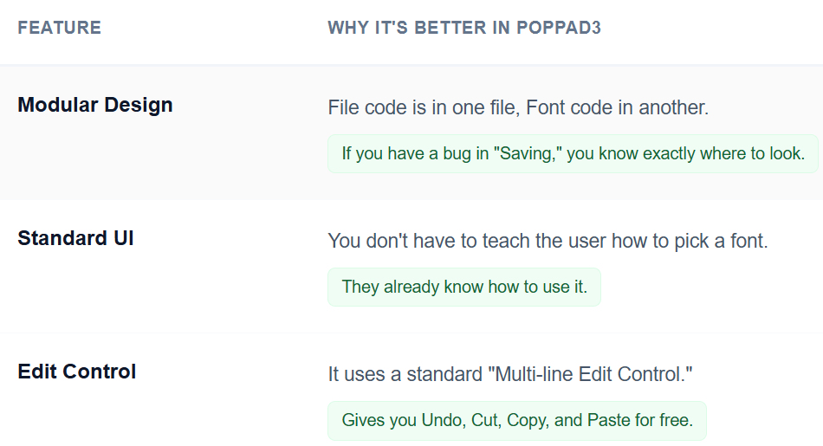

3. POPFIND.C: Searching the Text

This file manages the **Find** and **Replace** features. Since these are **Modeless** dialogs, they stay open while you work.

**Finding Text (PopFindFindText):** When you click "Find Next," the program doesn't just look at the screen; it looks at the "back-end" memory:

**Get the Text:** It grabs all the text inside the editor.

**The Scan:** It uses a standard search function (_tcsstr) to scan the document for the word you typed.

**Highlight & Scroll:** If it finds the word, it sends two messages to the editor:

* EM_SETSEL: This highlights the word (makes it blue).
* EM_SCROLLCARET: This automatically scrolls the window so you can actually see where the word is.

**Replacing Text (PopFindReplaceText)**

This is a two-step process. First, it finds the word. Then, it sends the EM_REPLACESEL message. This essentially "pastes" your new word directly over the highlighted one.

4. POPFONT.C: Changing the Style

This file lets the user pick any font installed on their computer (like Arial, Times New Roman, or Comic Sans).

**Choosing the Font (PopFontChooseFont)**

The program fills out a form called CHOOSEFONT.

* It asks Windows to show the **Common Font Dialog**.
* Once you pick a font and click "OK," Windows sends back a LOGFONT structure—a "recipe" that describes the font's name, size, and thickness (bold, italic, etc.).

**Applying the Font (PopFontSetFont)**

Once the program has the "recipe," it has to tell the editor to use it:

1. **Create:** It creates the actual font object based on the user's choice.
2. **Set:** It sends a WM_SETFONT message to the edit control. The text instantly changes to the new style.
3. **Clean Up:** It deletes the **old** font from memory. This is very important—if you don't delete old fonts, the computer will eventually run out of memory (a "memory leak").

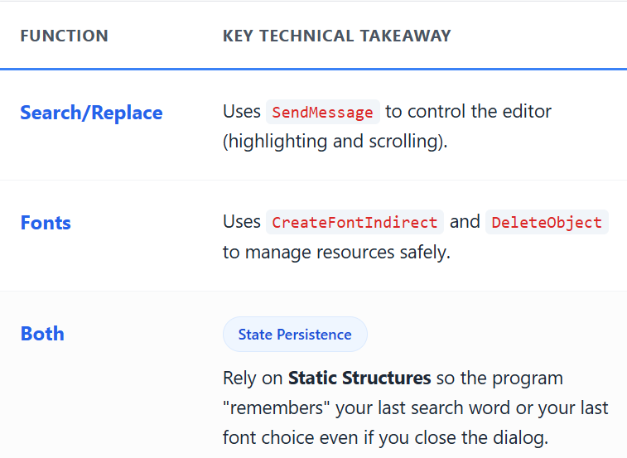

5. The Resources: Building the Shell

Think of **POPPAD.RC** and **RESOURCE.H** as the blueprint and the inventory list for your app’s interface.

* **The Blueprint (POPPAD.RC):** This file is where you "draw" the menus, define the "About" box, and set up your keyboard shortcuts (Accelerators). It tells Windows: "Put a 'File' menu here" or "Use this icon for the taskbar."
* **The Inventory (RESOURCE.H):** This is a simple list of nicknames for your buttons and menus. Instead of remembering that the "Save" button is number 40001, the code just uses the name IDM_FILE_SAVE. It makes the code much easier for a human to read.

6. POPFILE.C: The File Manager

This file handles the connection between the user’s mouse clicks and the computer’s hard drive.

**The "Universal Form" (OPENFILENAME)**

When you want to Open or Save, Windows asks you to fill out a "form" first. Instead of explaining every tiny detail of that form, here is what it actually controls:

* **Filters:** It limits what you see (e.g., "Only show .txt files"). This is done using a "Filter String" that the user sees in a dropdown menu.
* **Memory Buffers:** It prepares a "bucket" (a piece of memory) to catch the file path the user picks.
* **Behavior Flags:** These are like "on/off" switches. For example, you can flip a switch to make Windows ask: *"Are you sure you want to overwrite this file?"* before it actually saves.

7. How Open and Save Actually Work

The program uses two "twin" functions provided by Windows to do the heavy lifting:

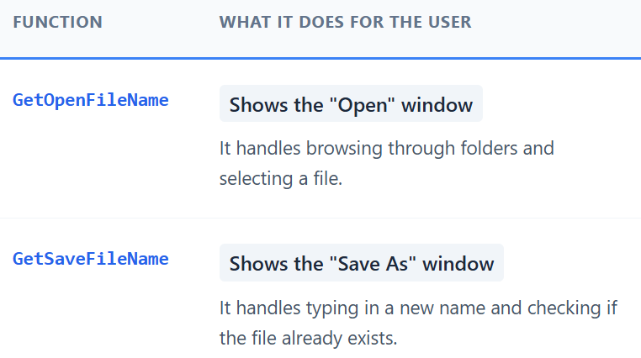

**The Shortcut:** The programmer creates the "form" (the structure) once and **reuses** it for both opening and saving. This is why the app "remembers" which folder you were just in—it keeps using the same piece of memory for both tasks.

8. Summary

* **Resources** handle the "Look" (Menus, Icons, Shortcuts).
* **RESOURCE.H** gives those looks "Names" so the code can talk to them.
* **POPFILE.C** handles the "Logic" of moving data to and from the hard drive using standard Windows windows.

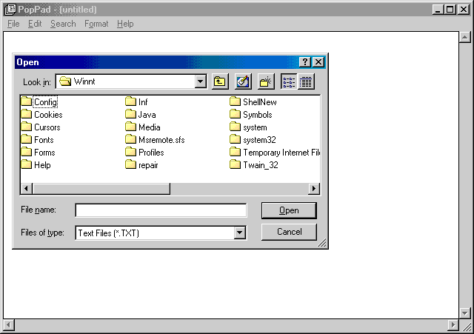

Unicode: The Universal Translator

Computers use different "alphabets" (encodings). Old programs use **ANSI** (basic English), while modern ones use **Unicode** (every language). POPPAD3 has to handle both.

**The Signature (Byte Order Mark):** When POPPAD3 saves a Unicode file, it puts a hidden "stamp" at the very beginning (0xFEFF).

**The Detective (IsTextUnicode):** When you open a file, the program looks for that stamp.

* If the stamp is there, it reads it as Unicode.
* If not, it assumes it's an old ANSI file and converts it so you can see it correctly.

**The Converter:** The program uses two "translators" called WideCharToMultiByte and MultiByteToWideChar to flip text back and forth between these formats.

1. Font Management: Creating and Cleaning

Managing fonts is like borrowing books from a library. If you keep borrowing and never return them, the library runs out of space (this is a "memory leak").

* **Start:** When the app opens, it creates a default font so the screen isn't blank.
* **Change:** When you pick a new font, the program **creates** a new one based on your choice.
* **Replace & Delete:** This is the most important step. Before using the new font, the program **deletes** the old one.
* **Finish:** When you close the app, it deletes the final font to leave the computer's memory clean.

2. The "Find" Conversation

The **Find and Replace** windows are **Modeless**, which means they are "floating" assistants. Because they are separate windows, they need a way to talk back to the main editor.

* **The Secret Code:** The program creates a custom message number using RegisterWindowMessage. Think of this as a private radio frequency that only the main window and the Find window can hear.
* **The Data Folder (FINDREPLACE):** This is a shared folder (a static structure) where both windows store the word you are looking for and whether you checked "Match Case."
* **The "Mailroom" Check:** As mentioned before, the "Mailroom" (Message Loop) uses IsDialogMessage to make sure your typing goes into the Find box when it's open, rather than accidentally typing into the document behind it.

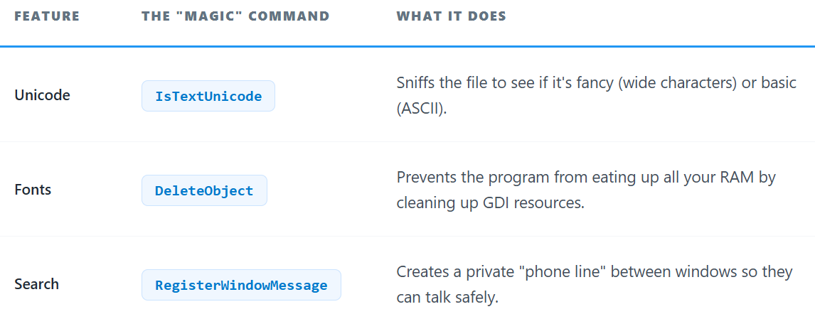

IN-DEPTH EXPLANATION OF COLORS3 PROGRAM WITH ADDITIONAL INSIGHTS

This section expands upon the previous explanation of COLORS3, delving deeper into technical details and providing additional insights into the code and its implications.

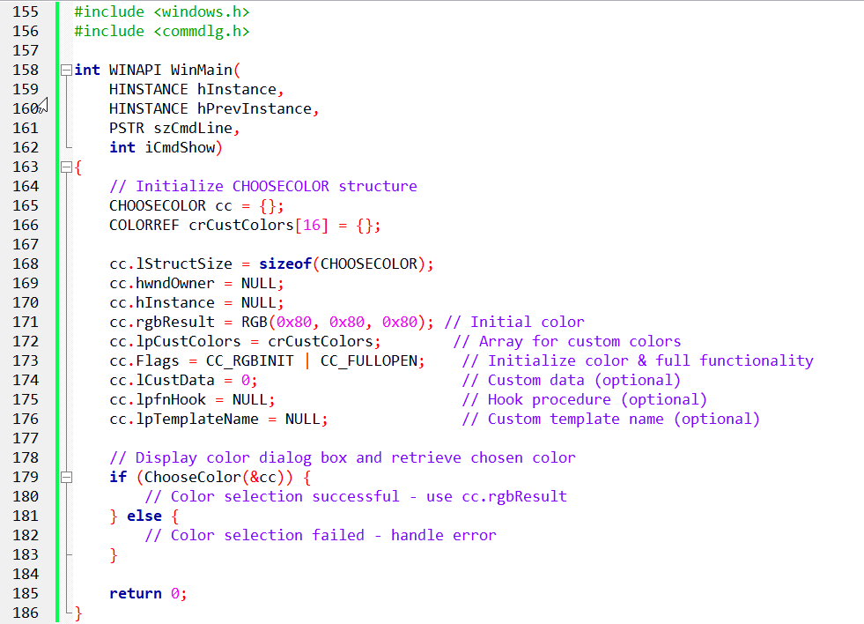

COLORS3: One Function to Rule Them All

In the previous versions (COLORS1 and COLORS2), we had to build our own scroll bars and logic. In **COLORS3**, the program just asks Windows: "Hey, show the user your official color-picking window."

1. The "Color Form" (CHOOSECOLOR)

Before calling the window, the programmer fills out a "form" (structure). Here’s what matters inside that form, without the technical jargon:

* **rgbResult (The Starter and Winner):** You put a color in here to show it first (like Red). When the user picks a new color, Windows overwrites this with the new choice.
* **lpCustColors (Custom Slots):** This points to a small list of 16 colors. This is where those "Custom Colors" you save in Windows programs are stored so they don't disappear.
* **hwndOwner set to NULL:** By setting this to nothing, the color box becomes an "independent" window. It isn't "stuck" to a parent window.
* **Flags:**
  + CC_RGBINIT: Tells the box to actually use the starting color you gave it.
  + CC_FULLOPEN: Automatically opens the "custom color" side of the window so the user doesn't have to click "Define Custom Colors."

2. How the Program Flows

The logic for COLORS3 is incredibly short:

1. **Fill the Form:** Set up the CHOOSECOLOR structure with your settings.
2. **Make the Call:** Run the function ChooseColor(&cc).
3. **The Wait:** The program pauses while the user plays with the rainbow picker and clicks "OK."
4. **The Result:** The function returns TRUE if they picked a color. You then look at the rgbResult field to see exactly what color they chose.

3. Why This is the Best Approach

**Minimalist:** You achieve a professional interface with almost zero effort.

**Standardized:** Users are already experts at using this window because they've seen it in every other Windows app since the 90s.

**Powerful:** It handles all the complex math of "Hue, Saturation, and Luminance" for you.

*End of chapter 11…*